**Modules**

**Assignment:**

Modules & workspace assignment

Create a Terraform module that provisions a *VPC, security groups (allowing SSH & HTTP)* , and an *EC2 instance* . Upload the module code to your github repo and reference the github source for your module block

The setup should use Terraform workspaces for different environments (dev, stage, prod) and allow users to specify the CIDR block of their choice.

Make use of -

Variables for user-defined inputs.

Locals for computed values.

Functions to format values dynamically.

link: https://spacelift.io/blog/what-are-terraform-modules-and-how-do-they-work

Steps:

* Let’s create module to create VPC, Security group and the EC2
* Modules will have 3 files, main.tf, variables.tf, and output.tf
* Let’s give it a try locally and then will upload this to the github
* Module main.tf

|  |
| --- |
| resource "aws_vpc" "test_vpc" {  cidr_block = var.vpc_block  tags = {  Name = var.vpc_name  }  }  resource "aws_subnet" "test_subnet" {  vpc_id = aws_vpc.test_vpc.id  cidr_block = var.subnet_block  availability_zone = var.availability_zone  tags = {  Name = var.subnet_name  }  }  resource "aws_security_group" "test_sg" {  name = var.security_groups_group_name  description = var.security_groups_desc  vpc_id = aws_vpc.test_vpc.id  ingress {  from_port = var.ssh_port  to_port = var.ssh_port  protocol = var.protocol  cidr_blocks = var.traffic_from_anywhere  }  ingress { #allowing http port  from_port = var.http_port  to_port = var.http_port  protocol = var.protocol  cidr_blocks = var.traffic_from_anywhere #from anywhere  }  }  resource "aws_instance" "workspace_instance" {  ami = var.ami_value  instance_type = var.ec2_type  subnet_id = aws_subnet.test_subnet.id  security_groups = [aws_security_group.test_sg.id]  availability_zone = aws_subnet.test_subnet.availability_zone  } |

module Variable.tf file

|  |
| --- |
| variable "vpc_block" {  description = "CIDR range"  }  variable "vpc_name" {  description = "Name of the VPC"  }  variable "subnet_block" {  description = "CIDR block of the subnet"  }  variable "subnet_name" {  description = "Name of the VPC"  }  variable "availability_zone" {  description = "The avaiblity zone"  }  variable "security_groups_group_name" {  description = "security group name"  }  variable "security_groups_desc" {  default = "Allow http and ssh ports"  description = "security group name description"  }  variable "ssh_port" {  default = "22"  description = "SSH port"  }  variable "http_port" {  default = "80"  description = "HTTP port"  }  variable "protocol" {  default = "tcp"  description = "tcp protocol"  }  variable "traffic_from_anywhere" {  default = ["0.0.0.0/0"]  description = "Allow traffic from anywhere"  }  variable "ami_value" {  description = "The AMI value"  }  variable "ec2_type" {} |

* Project main file main.tf

|  |
| --- |
| provider "aws" {  region = "ap-south-1"  }  module "ec2_creation" {  source = "./Modules/ec2_creation"  vpc_block = var.cidr_block  vpc_name = var.vpc_name  subnet_block = var.subnet_range  subnet_name = var.subnet_name  availability_zone = var.availability_zone  security_groups_group_name = var.security_groups_name  security_groups_desc = var.security_groups_desc  ami_value = "ami-00bb6a80f01f03502"  ec2_type = var.type  } |

* Project variable file variables.tf

|  |
| --- |
| variable "cidr_block" {  description = "Enter the CIDR range for the VPC"  }  variable "vpc_name" {  default = "test_vpc"  }  variable "subnet_range" {  description = "Enter the subnet block range"  }  variable "subnet_name" {  default = "test_subnet"  }  variable "availability_zone" {  default = "ap-south-1a"  }  variable "security_groups_name" {  default = "Test_SG"  description = "The name of the security group"  }  variable "security_groups_desc" {  default = "Allowing ssh and http ports"  }  variable "type" {  description = "Enter the instance type"  } |

* when we run the apply command, it will ask us to enter the cidr range for VPC and subnet and the instance type. (We have not provided the default values for these)  
  A screenshot of a computer

  AI-generated content may be incorrect.
* Moved the module code to the github and updated the module block  
  https://github.com/phaninandigam/Terraform_Modules_NPR.git  
  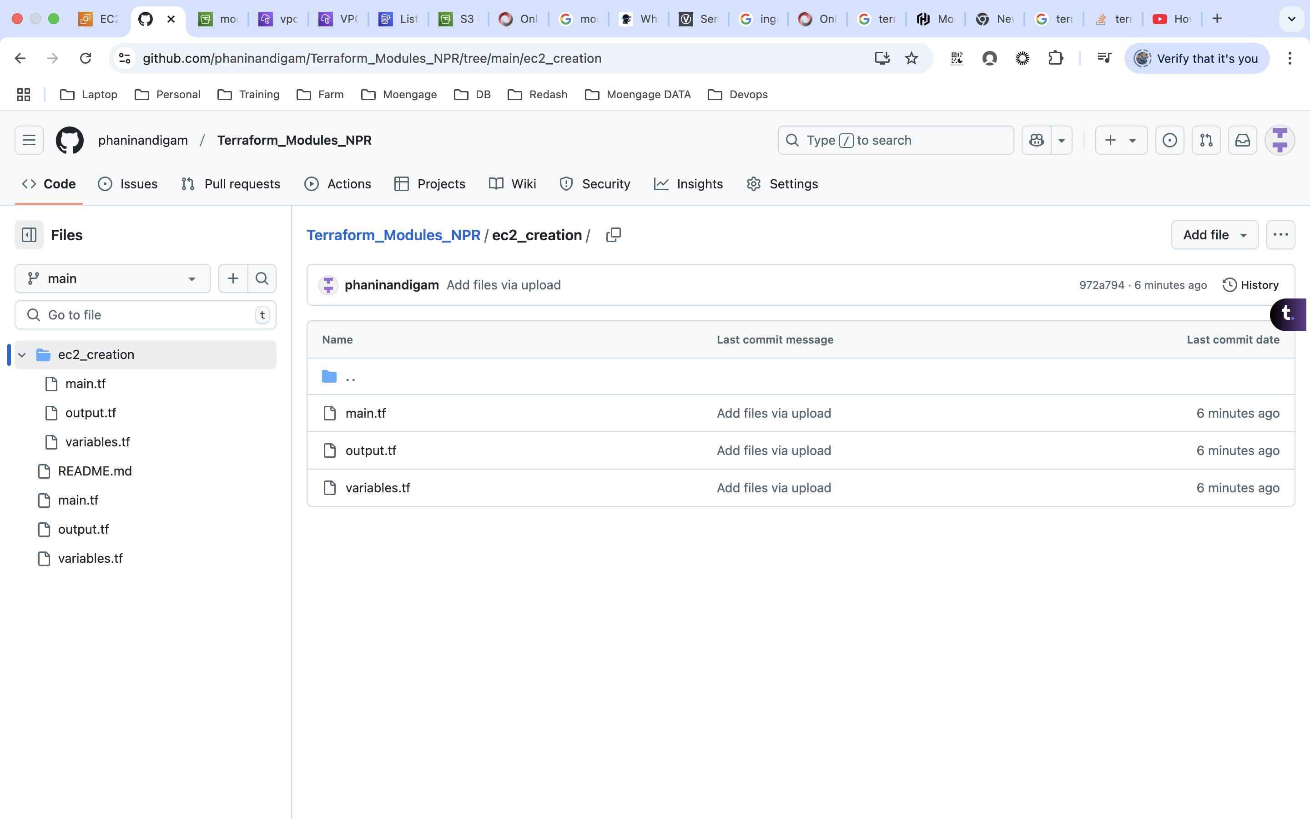

|  |
| --- |
| module "ec2_creation" {  source = "github.com/phaninandigam/Terraform_Modules_NPR/ec2_creation"  # source = "./Modules/ec2_creation"  vpc_block = var.cidr_block  vpc_name = format("%s_%s","${terraform.workspace}",var.vpc_name)  subnet_block = var.subnet_range  subnet_name = format("%s_%s","${terraform.workspace}",var.subnet_name)  availability_zone = var.availability_zone  security_groups_group_name = var.security_groups_name  security_groups_desc = var.security_groups_desc  ami_value = "ami-00bb6a80f01f03502"  ec2_type = var.type  ec2_name = format("%s_%s","${terraform.workspace}","ec2-Instance")  } |

* Will add workspaces now, I will be using s3 as a backend  
  terraform workspace new dev  
  terraform workspace new prod  
  terraform workspace new stage

|  |
| --- |
| terraform {  backend "s3" {  bucket = "modules-workspace-tfstate-files" #bucketname  key = "statefiles" #path  region = "ap-south-1"  # dynamodb_table = "terraform_state_lock_file"  use_lockfile = true  }  } |

* Now, based on the workspace, we will be adding the vpc, subnet and in the instance names  
  A screenshot of a computer

  AI-generated content may be incorrect.

|  |
| --- |
| module "ec2_creation" {  # source = "github.com/phaninandigam/Terrafrom_ec2_creation_modules"  source = "./Modules/ec2_creation"  vpc_block = var.cidr_block  vpc_name = format("%s_%s","${terraform.workspace}",var.vpc_name)  subnet_block = var.subnet_range  subnet_name = format("%s_%s","${terraform.workspace}",var.subnet_name)  availability_zone = var.availability_zone  security_groups_group_name = var.security_groups_name  security_groups_desc = var.security_groups_desc  ami_value = "ami-00bb6a80f01f03502"  ec2_type = var.type  ec2_name = format("%s_%s","${terraform.workspace}","ec2-Instance")  } |

Complete Code:

**main.tf**

|  |
| --- |
| provider "aws" {  region = "ap-south-1"  }  module "ec2_creation" {  source = "github.com/phaninandigam/Terraform_Modules_NPR/ec2_creation"  # source = "./Modules/ec2_creation"  vpc_block = var.cidr_block  vpc_name = format("%s_%s","${terraform.workspace}",var.vpc_name)  subnet_block = var.subnet_range  subnet_name = format("%s_%s","${terraform.workspace}",var.subnet_name)  availability_zone = var.availability_zone  security_groups_group_name = var.security_groups_name  security_groups_desc = var.security_groups_desc  ami_value = "ami-00bb6a80f01f03502"  ec2_type = var.type  ec2_name = format("%s_%s","${terraform.workspace}","ec2-Instance")  }  terraform {  backend "s3" {  bucket = "modules-workspace-tfstate-files" #bucketname  key = "statefiles" #path  region = "ap-south-1"  # dynamodb_table = "terraform_state_lock_file"  use_lockfile = true  }  }  locals {  instance = {  "default" = "t2.micro"  "dev" = "t2.micro"  "staging" = "t3.small"  "prod" = "t3.medium"  }  } |

**variables.tf**

|  |
| --- |
| variable "cidr_block" {  description = "Enter the CIDR range for the VPC"  }  variable "vpc_name" {  default = "test_vpc"  }  variable "subnet_range" {  description = "Enter the subnet block range"  }  variable "subnet_name" {  default = "test_subnet"  }  variable "availability_zone" {  default = "ap-south-1a"  }  variable "security_groups_name" {  default = "Test_SG"  description = "The name of the security group"  }  variable "security_groups_desc" {  default = "Allowing ssh and http ports"  }  variable "type" {  description = "Enter the instance type"  } |

**modules code:**

<https://github.com/phaninandigam/Terrafrom_ec2_creation_modules.git>